South Africa

## Respect for rule of law (ROL) data

The data set shows the data on the respect of the rule of law for the country.

## # A tibble: 19 x 5  
## country iso3c date ruleOfLaw ruleOfLawCategory4   
## <chr> <chr> <dbl> <dbl> <chr>   
## 1 South Africa ZAF 1996 0.0879 ROL moderately respected   
## 2 South Africa ZAF 1998 0.271 ROL moderately respected   
## 3 South Africa ZAF 2000 0.203 ROL moderately respected   
## 4 South Africa ZAF 2002 0.132 ROL moderately respected   
## 5 South Africa ZAF 2003 0.124 ROL moderately respected   
## 6 South Africa ZAF 2004 0.114 ROL moderately respected   
## 7 South Africa ZAF 2005 0.115 ROL moderately respected   
## 8 South Africa ZAF 2006 0.255 ROL moderately respected   
## 9 South Africa ZAF 2007 0.0949 ROL moderately respected   
## 10 South Africa ZAF 2008 0.0725 ROL moderately respected   
## 11 South Africa ZAF 2009 0.124 ROL moderately respected   
## 12 South Africa ZAF 2010 0.141 ROL moderately respected   
## 13 South Africa ZAF 2011 0.152 ROL moderately respected   
## 14 South Africa ZAF 2012 0.110 ROL moderately respected   
## 15 South Africa ZAF 2013 0.158 ROL moderately respected   
## 16 South Africa ZAF 2014 0.183 ROL moderately respected   
## 17 South Africa ZAF 2015 0.0888 ROL moderately respected   
## 18 South Africa ZAF 2016 0.116 ROL moderately respected   
## 19 South Africa ZAF 2017 -0.0112 ROL moderately disrespected

## Respect for rule of law (ROL) trend

The plot shows the trend of the respect for the rule of law for the country.

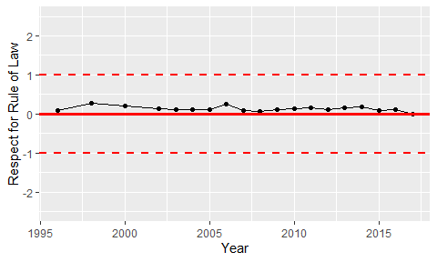

Trend of the Respect for the Rule of Law